to look into
- motor interface board schematic
- what makes the good ones so expensive
- fixed point math w/ fpga
- component selection for pcb
- stm32??
- hdl coder & fpga-in-the-loop simulation
- deliverable (what r the questions they ask)
- testing on the low voltage motor

- theory corner section of simplefoc

tonight:
- dc/dc *
- motor interface *
- ti doc *
- components
- soc mcu + fpga board **
- separate pcb layers?? *

6/23
- redo block diagrams
  - think the only thing that’s wrong is the pwm gen? obv feel free to correct/make your own but important for pcb; maybe worth getting checked?

- motor interface board schematic
  - b1 - switching regulator buck converter: 12 to 3v3
  - u1 - radio freq transceiver
  - u2 - DAC (SPI in, left and right throttles out????)
  - u3 and u4 - digital isolators, signals go from LV to MC
  - u5 - voltage level shifter: foot switch, brake switch, forward and reverse from 5 to 12V
  - have to look more at headers; i/o

- kelly motor controller datasheet
  - ch 1 introduction
    - sinusoidal waveform
    - “efficiency of 99%” how do you measure this
    - PC software/app for programming, can look at options they have maybe
  - ch 2 features & specs
    - fault detection & protection
    - battery & current & temp monitoring
    - default switch inputs: throttle, brake, reverse, forward, boost
    - default analog inputs: throttle, brake, motor temp
    - 3 hall sensors, open collector w/ pull up
    - regen brake features……
    - CAN? Bluetooth?
    - current sensing & voltage monitoring on phases
    - current multiplication: take less current from battery, output more current to motor - what happens normally w/ mosfets or special circuitry?
    - 10 to 20kHz operation freq, 48-96V, 100A continuous current
  - ch 3 wiring & installation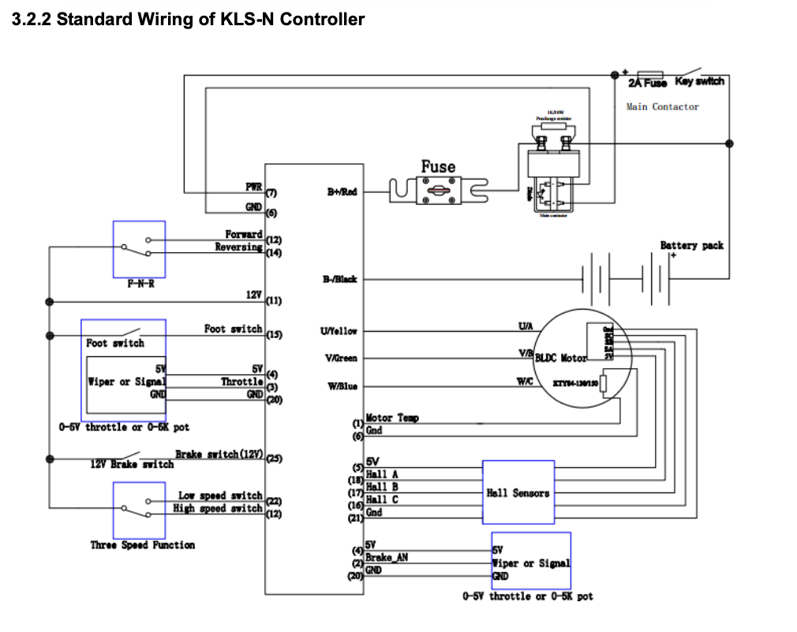
  - idk why i thought there would be a schematic in these datasheets 😭but i want to find a high voltage one + teardown on youtube or something. + can you unscrew it?

- prohelion motor controller datasheet
- datasheet
  - efficiency maps (mathematical models + lab testing)
  - CAN bus for telemetry, motor temp can be measured from here
  - requires cooling/external heatsinking
- user manual
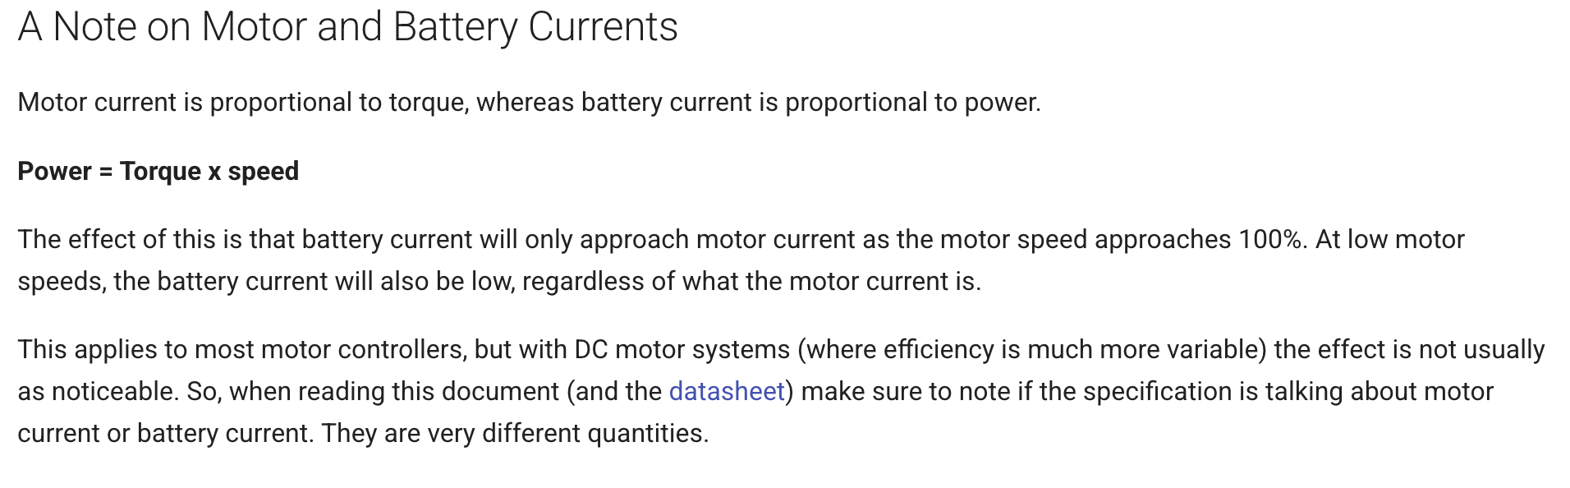
- thought this was interesting
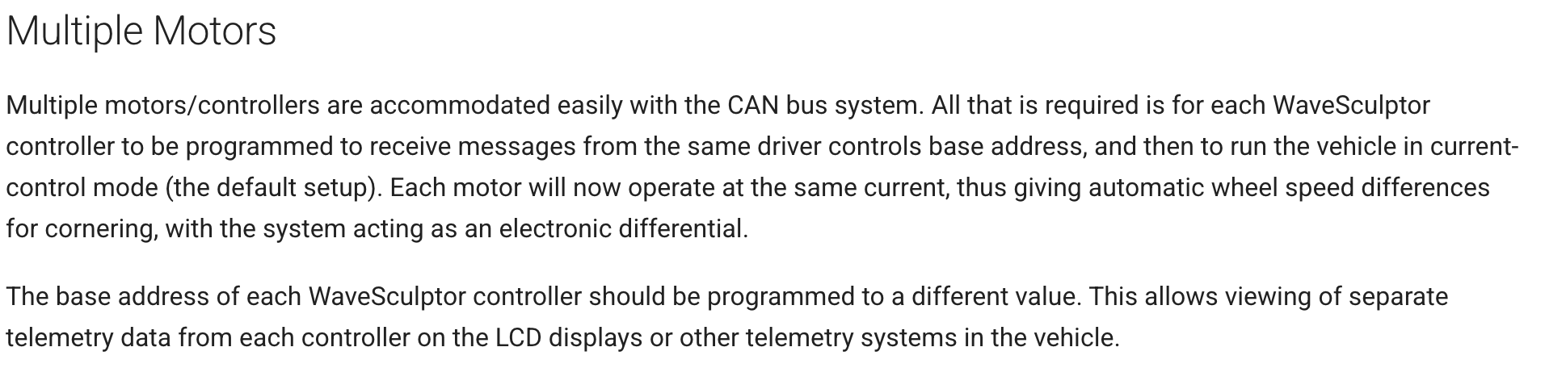
- whatever this means

- regen braking grrrr
- assumes thermistor is on the motor
- “isolation barrier rated to 1kV continuously between the CAN bus, the DC bus, and the Motor position connection”
- testing overview: low voltage before high, pc software before driver controls
- included the connector/cabling they recommend

- high voltage pcb, separating high & low
  - looks like a good resource in general, but safety section of this prob relevant: https://www.reddit.com/r/AskElectronics/wiki/index/

  - main takeaway is that even though most of this is very layout dependent, component selection matters

  - creepage distance (space in between conductors along surface)
  - clearance distance (space in between conductors in the air)
  - thicker trace width, more space between layers
  - isolation slots (physical cutouts)
  - separate ground plans for high and low, general dedicated layers
  - wire thickness for i/o + fuses? (see HV wiring specifications in elec. system vdr)

  - youtube channels: robert feranec, phil’s lab, eevblog
  - should look at dc/dc (which is only high voltage board other than motor interface?) for inspo

- solar vdrs
- battery
  - one cell: 3.6V
  - aux pack for startup: 12V, max charge 5.4A, max discharge 180A
    - supposed to provide power during faults to low voltage stuff as well…
- battery protection
  - 1 pack = 16 cells in parallel
  - 26 packs in series
  - max discharge 90A, 93.6V??? doesn’t sound right
  - relay board operation
- electrical system
  - lowkey there’s a current sensor in the high voltage schematic that’s going to the BMS. can we use that
- solar collector
  - panel arrangement & specs
  - 1383.12W estimated power production. ~350 cells in total

